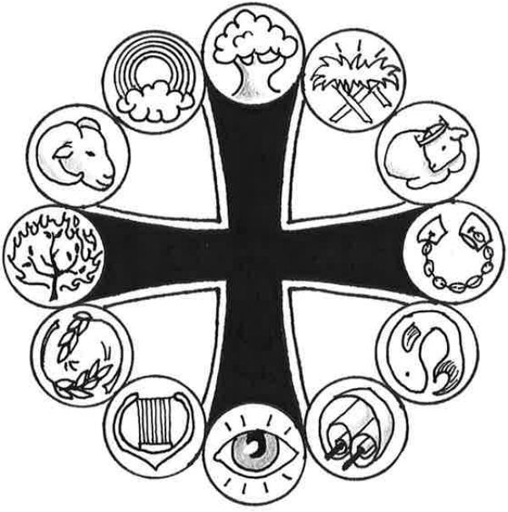
Prominent People of the Bible

Abraham

“All peoples on earth will be blessed through you.” Genesis 12:3

“Father Abraham had many sons / Many sons had Father Abraham / I am one of them and so are you / So let’s all praise the Lord!”

These are the words of a song often sung by children in Sunday School or at Vacation Bible School. Abraham was an Old Testament believer who received a very special promise from God. Even though he and his wife Sarah were very old and well past the age of child-bearing (at least, humanly-speaking), the Lord promised to give a son to this childless couple.

It was another 25 years – when Abraham was 100 and his wife Sarah was 90 – before the Lord’s promise was fulfilled. But then it happened. Baby boy Isaac was born! How happy Abraham and Sarah were for this precious gift of life! How wonderful to be blessed according to the Lord’s wonderful promise!

This miraculous birth serves as an amazing example of God’s gracious love. But there’s more! Not only had the Lord promised Abraham a son in his old age, he also promised that the entire world would be blessed through Abraham because of his son. Isaac was the first of many descendants from Abraham, but the greatest descendant of all was the Savior of the world, Jesus Christ!

Not only did Abraham and Sarah receive a great blessing in the birth of their son, but you and I and all people have been blessed as well, just as God had promised Abraham! We’ve been blessed through that Savior who came as one of Abraham’s descendants. He was born into this world to free us from the guilt of sin. His sacrificial death gives us eternal life with God. His great resurrection from the dead has given us ultimate victory over the grave. And now from his glorious throne in heaven, he exercises his saving will over all things. Through this descendant of Abraham, all peoples on earth have been blessed!

Because of Abraham’s connection to the Savior, Christians often refer to themselves as “children of Abraham.” Through the life and death of Jesus Christ, we’ve been brought back into God’s family. Through faith in our Savior, we are God’s blessed people – just like Abraham!

To celebrate our place in God’s family, we sing with the children: “Let’s all praise the Lord!”
_____________________________________________________________________________

Graphic for Abraham: Ram
God provided a ram to be a substitute sacrifice for Isaac, Abraham's son. This life-saving substitute foreshadowed God's sacrifice of Jesus in our place.
More information is located online at WhatAboutJesus.com. Look for the What About … Prominent People link.

